Image Classification Python Codes

In DeepLearning/Template_Match folder

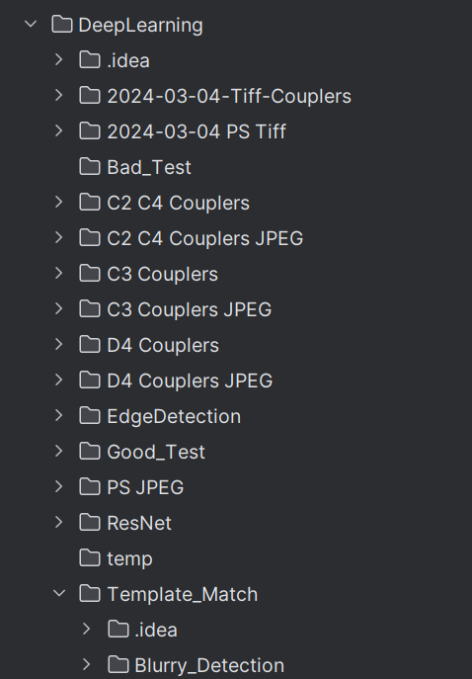

There are basically 3 important package in this folder:

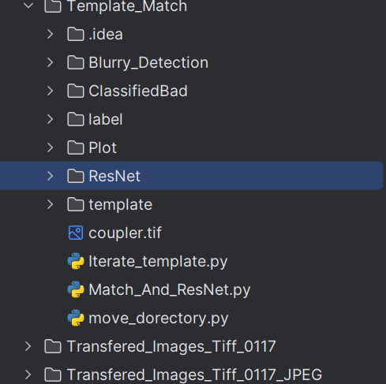

## ResNet

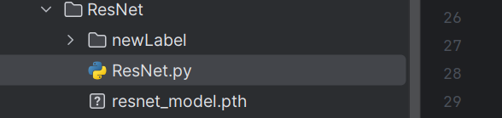

newLabel:

label for good and bad devices, By **manual**, for your training

## resnet_model.pth:

saved trained model

## ResNet.py:

Training the model file.

## Plot

This is the package that do some plotting, for time distribution, histogram and color coordinate map

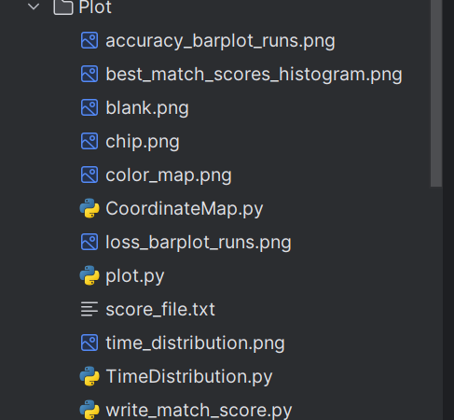

For histogram:

This is for plotting the score histogram given by template match,

Just run **histogram.py**

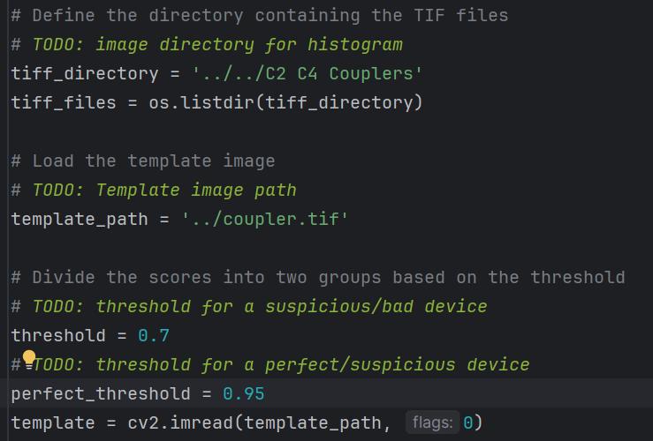

Inputs are given in TODO

For color map

This is for plotting the score on the chip

First run the **write_match_score.py**

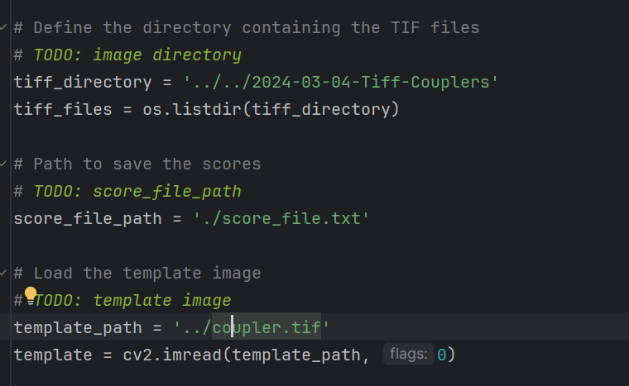

Then we will have the score file, then we need to draw it on the chip, so we need a chip photo, and an offset (since the color map is unlikely to be spread all over the chip but a particular part of a chip).

You need to manually assess your “part of chip” image(background image) offset to the zero point of chip, since points coordinate are in their names, so we need to know their offset to the background image.

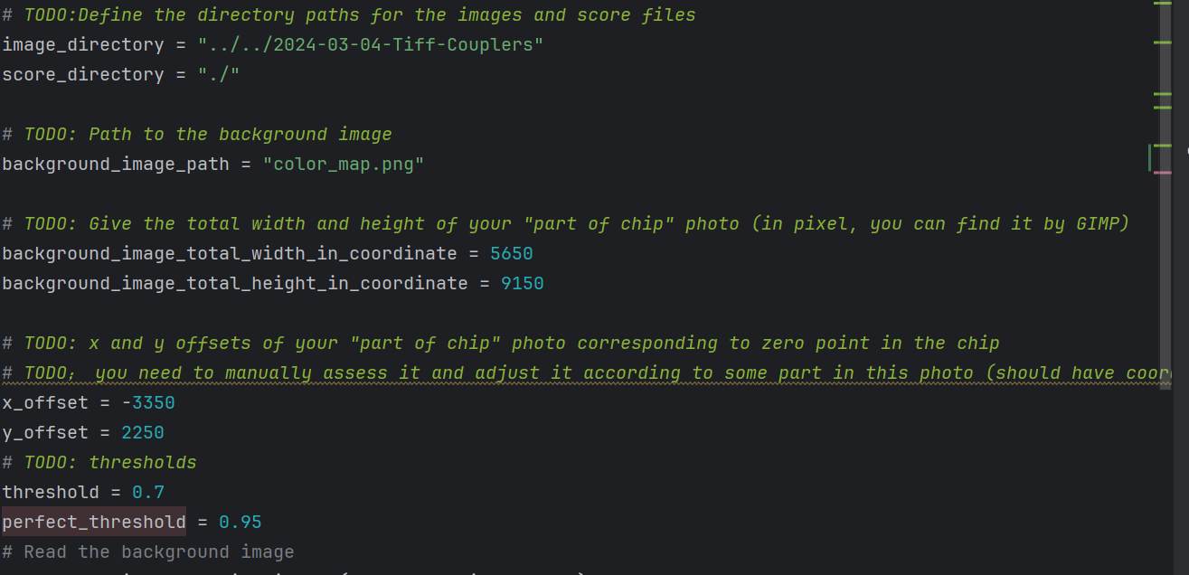

Time distribution

I don’t think you need this one, since its quite easy to generate.

## Blurry detection

This is for detecting the blurry images (not included in our standard process yet)

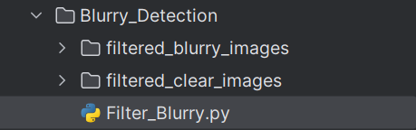

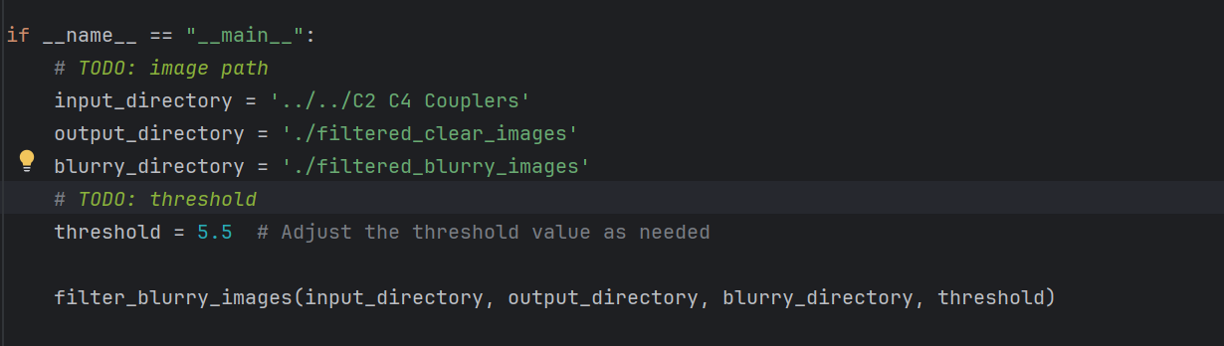

## Template Match (Most important part)

Iterate Template

**Iterate_template.py**

Inputs:

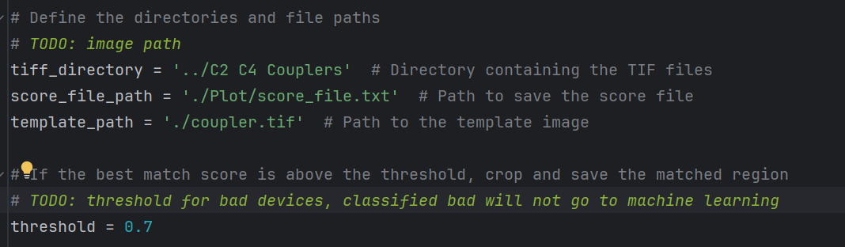

**Match_And_Resnet.py**

This is for using the previously trained model to classify the images, first do template match, images that are lower than threshold will automatically be bad devices, and higher than threshold images will go through the model to continue classifying.

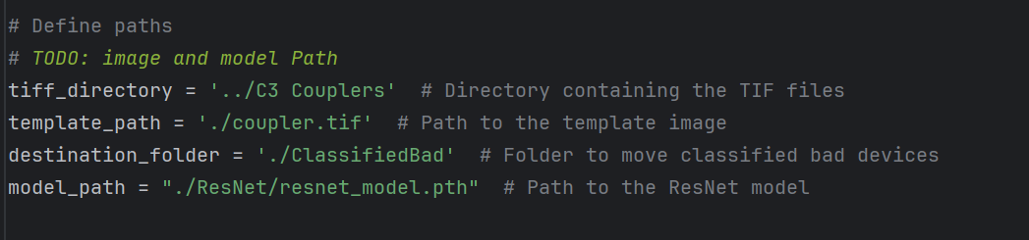

And the bad device images will be moved to ./ClassifiedBad folder.